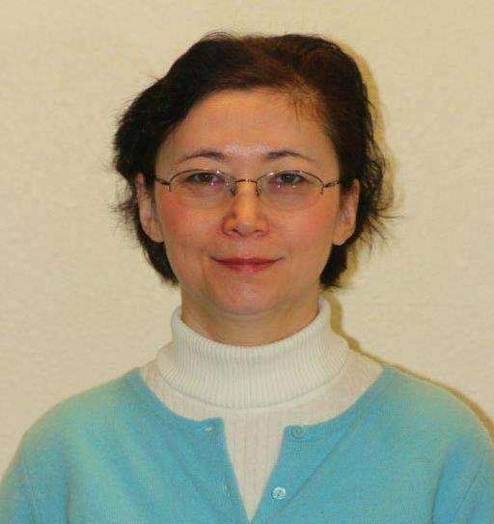
Name: Svetlana F. Khaiboullina
Position: Leading Scientist, Institute of Fundamental Medicine and Biology, Kazan Federal University.
Address: Kazan Federal University, Institute of Fundamental Medicine and Biology, Department of Genetics, Kremlevskaya St 18, Kazan, 420008, Tatarstan, Russian Federation.
E-mail: sv.khaiboullina@gmail.com
Research area:
Infectious diseases, viral hemorrhagic fevers: prevention and treatment. Gene and cell therapy, neurodegenerative, autoimmune and infectious diseases. Chemical compounds screening for anti-cancer and anti-viral therapies.
Expertise:
Cytokine and gene expression analysis. Genomics, transcriptomics and proteomics. Work in the BSL3 level safety laboratory. Work with viruses in BSL2 and BSL3 level containment laboratories (hemorrhagic fever viruses, herpes viruses, etc); experimental model for autoimmune disease, tumor and transplantation
Key equipment:
BD FACS Area III cell sorter, Laser scanning microscope LSM 780 (Carl Zeiss), Bio-Plex 200 Systems (Bio-Rad), Bactrox Hypoxia Dual Chamber, In vivo imaging system IVIS Spectrum Imaging System, Easy LDI Microcirculation Camera, Laser Doppler Imager moorLDI2, Tissue Oxygenation Monitor moorVMS-OXY.
Top 5 publications:
- Valente AX, Oliveira PJ, Khaiboullina SF, Palotás A, Rizvanov AA. 2013. Biological insight, high-throughput datasets and the nature of neuro-degenerative disorders. Curr Drug Metab. 14:814-818
- Khaiboullina SF, Morzunov SP, Hall MR, De Meirleir KL, Rizvanov AA, Lombardi VC. 2013 Human dendritic cells transfected with a human papilloma virus-18 construct display decreased mobility and upregulated cytokine production. Int J Oncol. 43:1701-1709
- Lombardi VC, Khaiboullina SF. 2014. Plasmacytoid dendritic cells of the gut: Relevance to immunity and pathology. Clin Immunol. 153:165-177
- Khaiboullina SF, Martynova EV, Khamidullina ZL, Lapteva EV, Nikolaeva IV, Anokhin VV, Lombardi VC, Rizvanov AA. 2014. Upregulation of IFN-γ and IL-12 is associated with a milder form of hantavirus hemorrhagic fever with renal syndrome. Eur J Clin Microbiol Infect Dis. 33:2149-56
- Khaiboullina SF, DeMeirleir KL, Rawat S, Berk GS, Gaynor-Berk RS, Mijatovic T, Blatt N, Rizvanov AA, Young SG, Lombardi VC. 2014. Cytokine expression provides clues to the pathophysiology of Gulf War illness and myalgic encephalomyelitis. Cytokine. 72:1-8
Editorial and expert responsibilities:
- Fulbright Scholar

